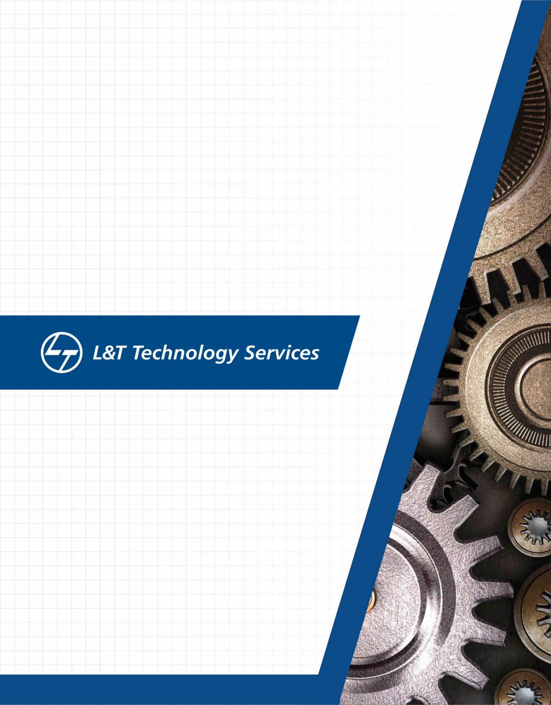./

Learning Report – Applied SDLC and Software Testing

Course Code: <CODE>



VINAY B J

99002648

|  |  |  |  |  |  |
| --- | --- | --- | --- | --- | --- |
| **Ver. Rel. No.** | **Release Date** | **Prepared. By** | **Reviewed By** | **Approved By** | **Remarks/Revision Details** |
| 1.1 | 17/09/2020 | Vinay B J |  |  |  |
| 1.2 | 18/09/2020 | Vinay B J |  |  |  |
| 1.3 | 19/09/2020 | Vinay B J |  |  |  |
|  |  |  |  |  |  |
|  |  |  |  |  |  |

**Document History**

# 

# Contents

Contents 3

Table of Figures: 4

Checklist 4

Activity 1 – System/Software Development 5

1.Introduction 5

1.1. Research: 5

1.2.Cost Gradation: 6

2.Product Definition: 6

3.SWOT Analysis: 7

4.Requirements: 8

4.1 High level requirements: 8

4.2 Low level requirements: 8

5.System Design 9

5.1 Data Flow Diagram: 9

5.2 Sequence Diagram: 9

5.3 Activity Diagram: 10

5.4 Class Diagram: 11

6.Test Plan 12

7. References 13

Appendix 15

Activity 2 –Agile Concepts 20

THEME: HEADPHONES 20

EPIC: 20

USER STORIES: 20

Activity 3 – Project 21

1.Introduction 21

2.Requirements 21

2.1 High Level Requirements: 21

2.2 Low Level Requirements: 22

3.System design 22

3.1 Use case Diagram 22

3.2 Activity Diagram 23

4.Test Plan 24

5.Appendix 25

6.References 25

# Table of Figures:

Fig.1 Data flow Diagram…………………………………………………………………………………………………9

Fig.2 Sequence Diagram…………………………………………………………………………………………………9

Fig.3 Activity Diagram…………………………………………………………………………………………………….10

Fig.4 Class Diagram………………………………………………………………………………………………………..11

Fig.5 Sequence Diagram for calculator…………………………………………………………………………..21

Fig.6 Class Diagram for calculator…………………………………………………………………………………..22

# Checklist

* Installation of SW on Phone and Desktop
* Registering LTTS credentials
* Reacting to Polls and communicating on Teams and Yammer
* Using Step-In credentials for GitHub for Activity 2
* Creating New GitHub account using LTTS credentials

# Activity 1 – System/Software Development

**HEADPHONES**

# 1.Introduction

## 1.1. Research:

* In 1880’s, the first headphones were used by telephone operators.
* single earpiece that rested on the user’s shoulder.
* weighed over 10 pounds.
* In 1910 – Nathaniel Baldwin began manufacturing the first modern headphones.
* consisted of two sound receivers, each containing a mile of copper wiring, attached to the operator's headband.
* In 1979, Sony invented the Walkman, creating a need for portable headphones.
* A lightweight set of MDR-3L2 headphones was included with the portable cassette player.
* The 3.5 mm headphone jack was also made popular.
* Both the earbud and the in-ear headphone made their way onto the scene in the 1980’s.
* In 1997, the first neckband headphones were introduced by Sony.
* more comfortable than in-hear headphones,
* neckband headphones sound great and are easy to wear.
* In 2001, Apple launched iPods.
* smaller, lighter, and faster than anything before.
* In the year 2004, wireless headphones were invented.

## 1.2. Cost Gradation:

* The first headphone(1880’s) has a subscription service of 5 euros (approx. ₹450) per annum.
* Sony’s Walkman was costing around US$200 in 1997.
* Apple’s iPod were costing around US$400 in 2001.
* Wired headphones will cost around ₹500-₹1000.
* The price of a Wireless (Bluetooth connected) Headphones will starts from ₹1500.

|  |  |
| --- | --- |
| Best Bluetooth Headsets Models | Price |
| Realme Buds Air Bluetooth Headset | ₹3999 |
| Boat Rockerz 400 Bluetooth Headset | ₹1499 |
| Jabra Talk Bluetooth Headset | ₹4149 |
| One plus Bullets Wireless Z Bluetooth Headset | ₹1999 |

# 2.Product Definition:

The proposed wireless headphones should have:

Long Battery life - Lithium-ion batteries are used in Bluetooth headphones which ranges from 8hrs to 10 hrs. Normally the voltage of the battery is about 4.2V.

Increasing Bluetooth connectivity - Bluetooth audio devices can be connected from up to 30 feet. Depending on the Bluetooth technology the connection can be more stable. Using higher version of Bluetooth can increase its connectivity range to up to 50 feet.

Comfortable – low-weight headphones are a lot more convenient to travel around. It should be portable (easy to carry).

# 3.SWOT Analysis:

Strengths:

* Comfortable to wear.
* Strong bass and Noise cancellation.
* Better battery life.
* Water resistant.
* Value for money.

Weakness:

* More expensive.
* Breakage if not handled carefully.

Opportunities:

* Growth in headphone replacement market.
* Multiple application of headphone.
* Increasing adoption of earphones & headphones during a workout.

Threats:

* Technology is changing every day.
* Competition from other companies.
* Fake products with cheaper rates.

# 4.Requirements:

## 4.1 High level requirements:

|  |  |
| --- | --- |
| ID | Description |
| H_01 | Should be wireless |
| H_02 | Should have long Bluetooth connectivity |
| H_03 | Should have longer battery life |
| H_04 | Value for money Product |
| H_05 | Noise cancellation |

## 4.2 Low level requirements:

|  |  |
| --- | --- |
| ID | Description |
| L_01 | Battery: lithium ion battery is used which normally produces 4.2V voltage. |
| L_02 | Bluetooth: Higher version of Bluetooth should be used for long distance connectivity. |
| L_03 | Microphone: for attending calls |
| L_04 | Micro USB charge port: for charging |
| L_05 | Speakers: to create sound, they consist of magnet, coil |
| L_06 | Electric wires: for connection |

# 5.System Design

## 5.1 Data Flow Diagram:

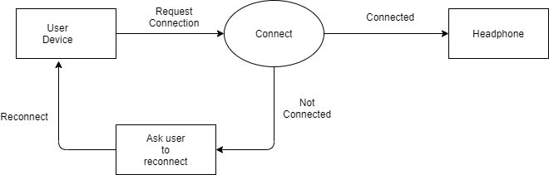

Fig.1 Data Flow Diagram

## 5.2 Sequence Diagram:

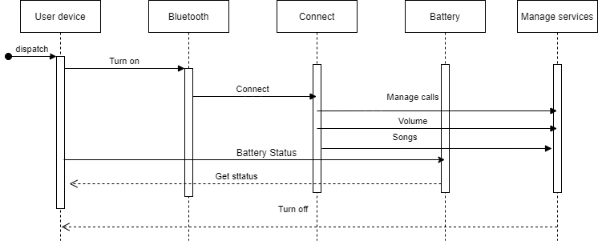

Fig.2 Sequence Diagram

## 5.3 Activity Diagram:

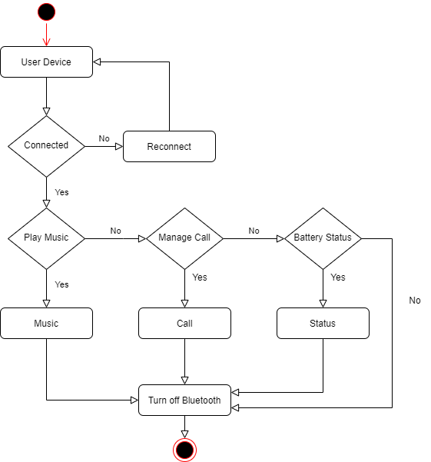

Fig.3 Activity Diagram

## 5.4 Class Diagram:

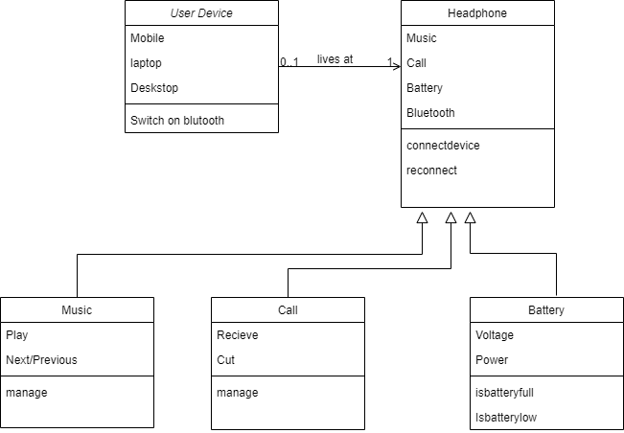

Fig.4 Class Diagram

# 6.Test Plan

|  |  |  |  |  |  |
| --- | --- | --- | --- | --- | --- |
| ID | Description | Pre-Condition | Expected Input | Expected Output | Actual Output |
| T_01_L_02 | Bluetooth | Connected/not | Switch on Bluetooth | Connected |  |
| T_02_L_02 | Bluetooth | Connected/not | Switch on Bluetooth | Unable to connect please reconnect |  |
| T_03_L_01 | Battery | Charging/not | Pass current | Charging |  |
| T_04_H_01 | Battery Status | Battery in good condition? | Pass current | Get status |  |
| T_05_H_05 | Noise Cancellation | Clearly audible/not | Play Song | Hear song with no background noise |  |
| T_06_L_03 | Microphone | Hear surrounding noise/not | Get call | Able to answer calls |  |
| T_07_H_05 | Sound Quality | Answer call/not | Play Music | Audible clearly |  |
| T_08_L_02 | Bluetooth Connectivity | Able to connect at 50-feet distance? | 50-feet distance between objects | Connected to device |  |
| T_09_L_02 | Bluetooth Connectivity | Able to connect beyond 50-feet distance? | Greater than 50-feet distance between objects | Disconnected |  |
| T_09_L_02 | Bluetooth Connectivity | Able to connect when obstacle placed between object | Place an obstacle between objects | Disconnected |  |
| T_10_L_05 | Speakers | Working/not | Pass Sound waves | Able to hear sound |  |

# 7. References

1. <https://en.wikipedia.org/wiki/Headphones>
2. <https://coolmaterial.com/roundup/history-of-headphones/>
3. <https://www.cnet.com/news/a-headphone-buyers-guide-to-specifications/>
4. <https://app.diagrams.net/>
5. <https://www.powerelectronics.com/markets/mobile/article/21853888/manage-batteries-better-in-bluetooth-headsets>

# Appendix

1.Git

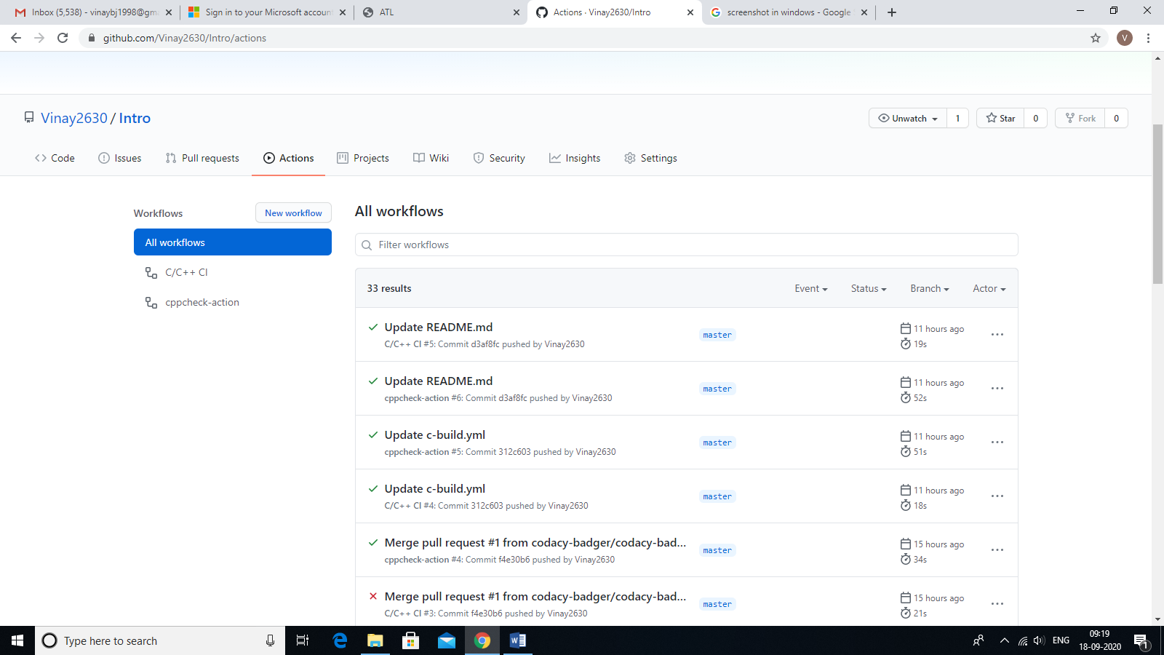

2.Make

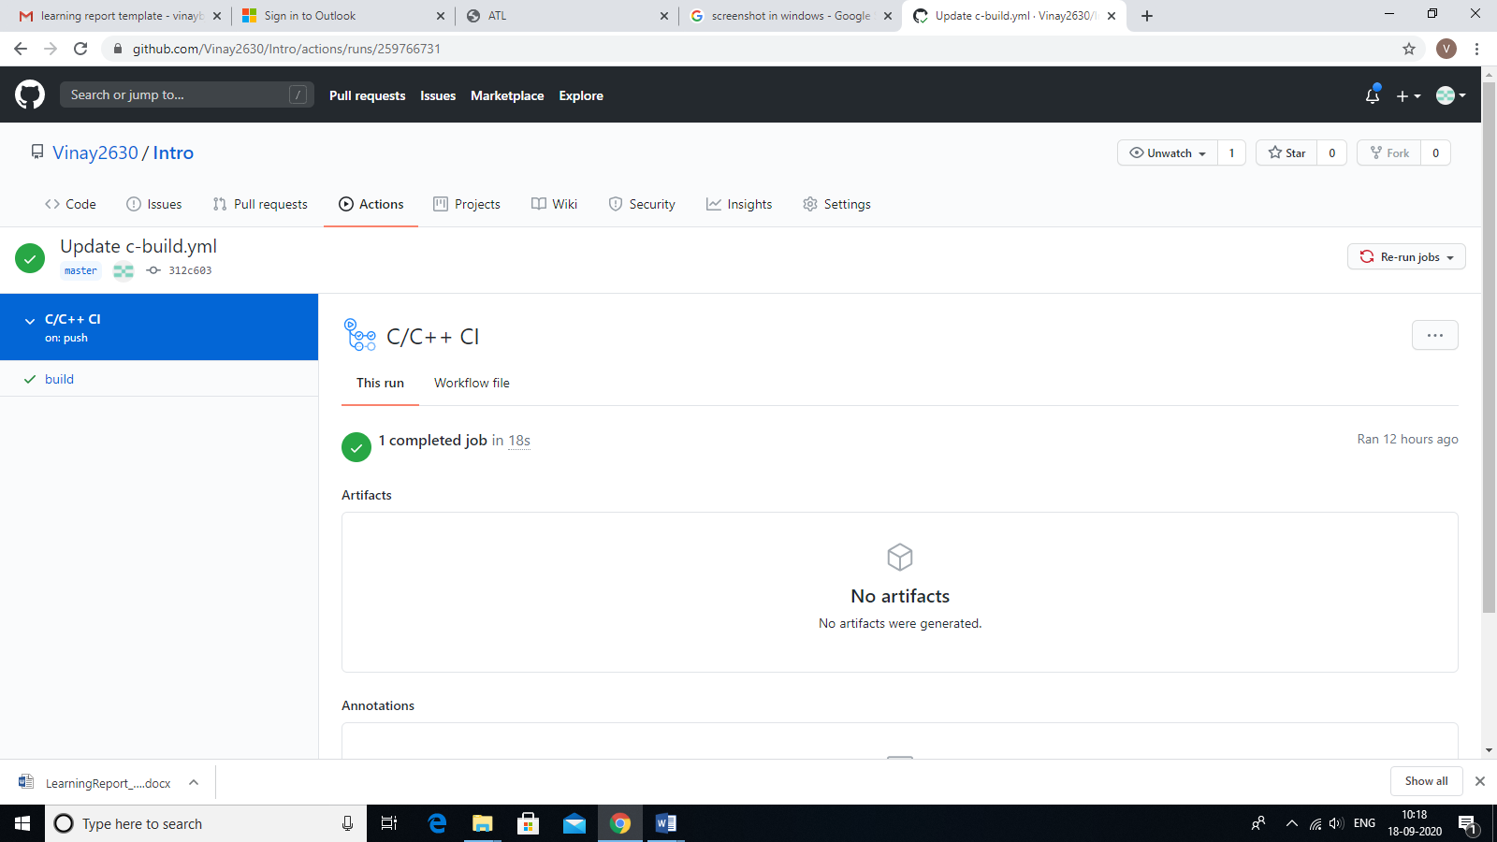

3.Build

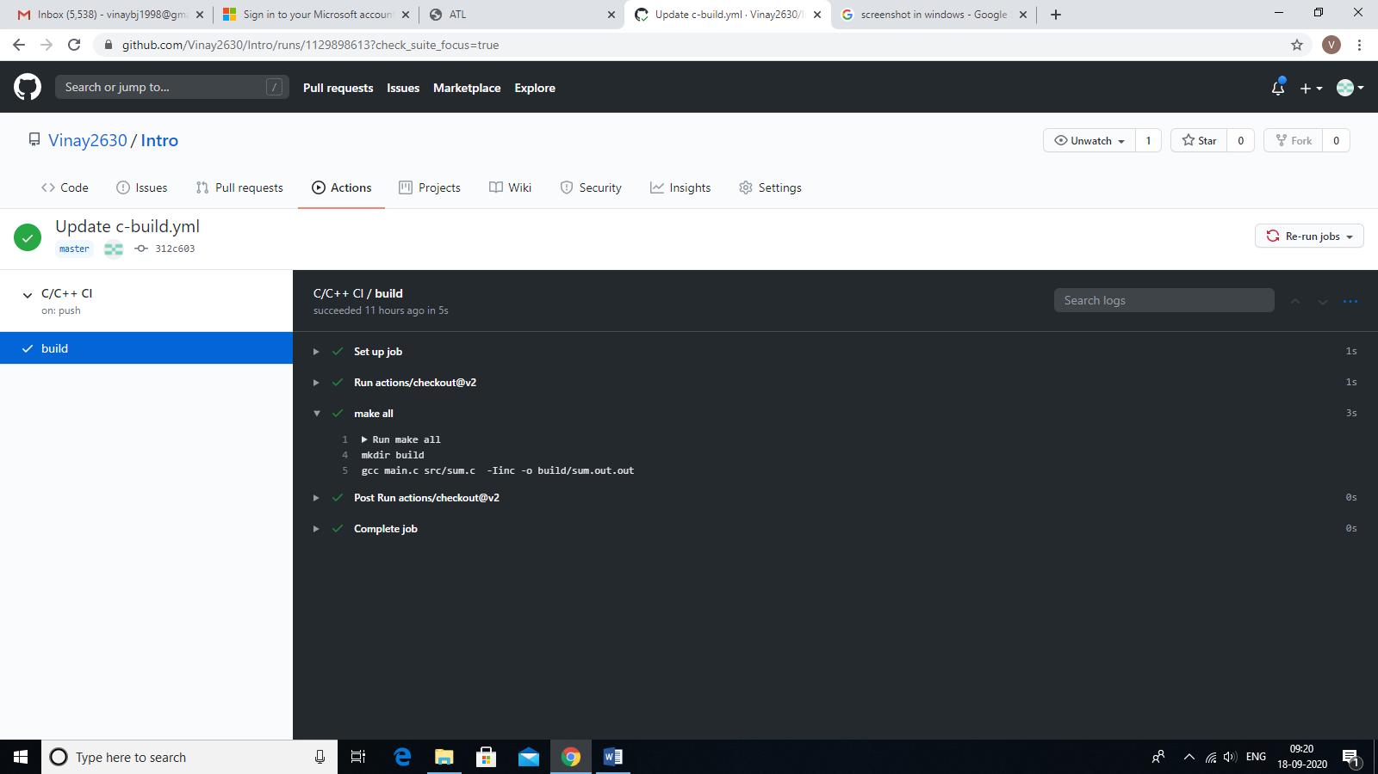

4.Code Quality

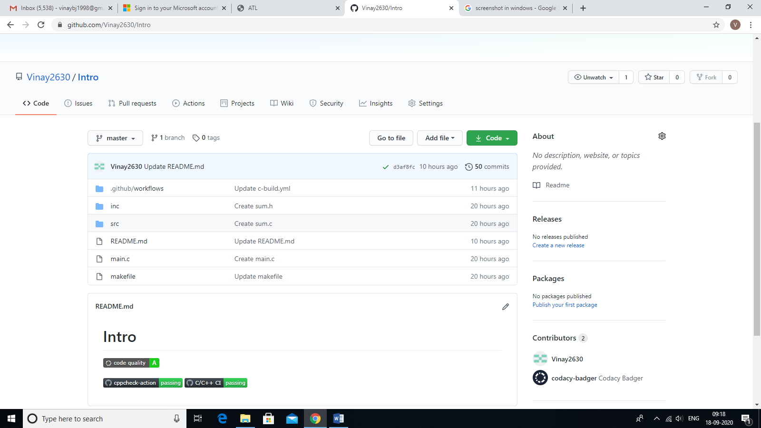

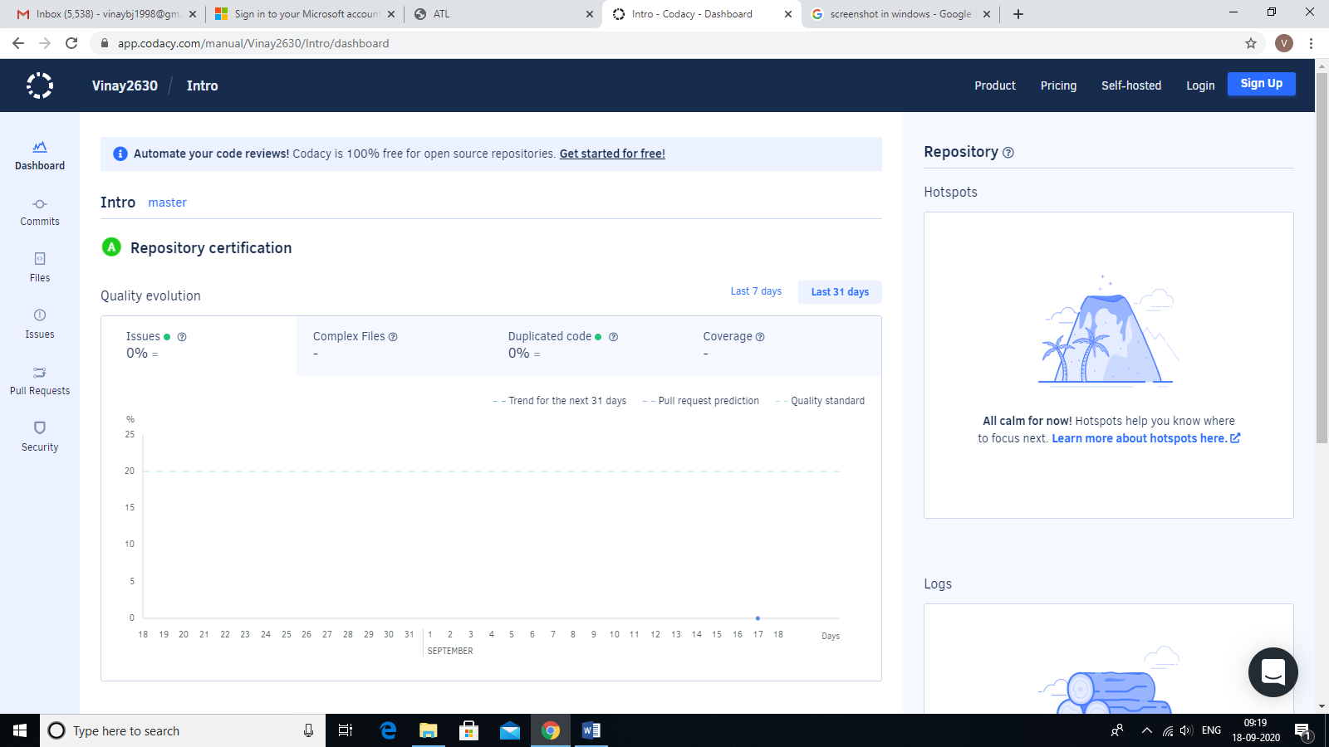

5.Cppcheck

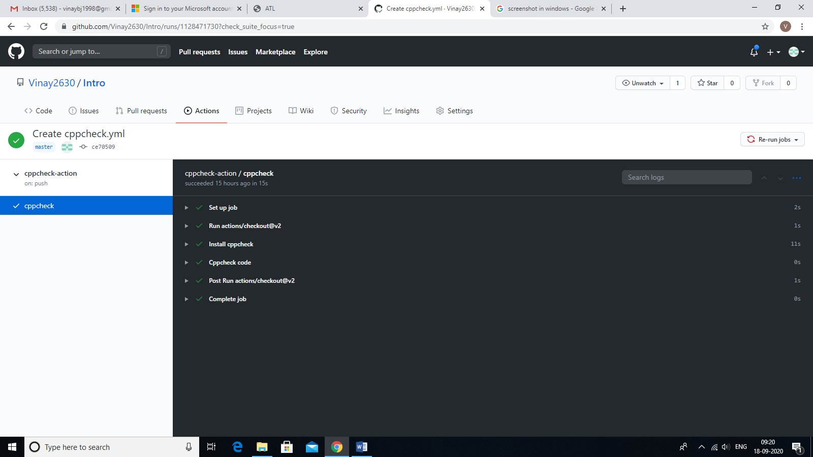

**Reference:**

<https://github.com/Vinay2630/Intro>

# Activity 2 –Agile Concepts

## THEME: HEADPHONES

To build a wireless headphone that should have a long battery life, long distance connectivity, portable and comfortable to wear.

## EPIC:

1. To build an effective Bluetooth headphone where, there should be a high-power battery for better battery backup, higher version of Bluetooth to support long distance connectivity.
2. To build headphones with good speakers and earbuds, must have high bass and noise cancellation. These features will be available to customers with affordable cost.

## USER STORIES:

1. It should be a Wireless headphone which should have Bluetooth connectivity,
2. The headphone must have large battery backup that should last for at least 10 hours after continuous usage. It should be comfortable to use and should not be more expensive.
3. The headphone should have high bass and should have noise cancellation and value for money product.

# Activity 3 – Project

# 1.Introduction

A calculator app is one of the most basic yet important apps on your phone. You need to deal with calculations every day and a calculator app allows you to use your smartphone for all the calculations on the go. Even though the default calculator app in most Android smartphones today is fairly feature packed and capable enough to handle a few complex equations. If you need a scientific calculator that can help you with all types of calculations and math problems, you will have to go for a third-party calculator app.

The calculator we have designed will have,

* Simple Calculations like addition, subtraction, multiplication, division and modulo division.
* Scientific Operations like nth power of a number, square root of a given number, factorial of a number and multiplicative inverse of a number.
* Conversion operations like currency conversion (US Dollars to Indian Rupees), Length conversion (Feet to Inches) and time conversion (Hours to Minutes).

# 2.Requirements

## 2.1 High Level Requirements:

|  |  |
| --- | --- |
| ID | Description |
| H_01 | A mobile calculator app that should perform simple calculations, scientific calculations and conversions. |
| H_02 | The calculator is developed using standard C language and should run on all machines supporting gcc compiler. |
| H_03 | Should display following menu bar to users like-1.Add, 2.Subtract, 3.Multiply, 4.Divide, 5.Modulus, 6.Power, 7.Square root, 8.Factorial, 9.Inverse, 10.Currency,  11.Length, 12.Time, 13.Exit |

## 2.2 Low Level Requirements:

|  |  |
| --- | --- |
| ID | Description |
| L_01 | Should exit when entered 13 |
| L_02 | Prevent users from divide by zero error. |
| L_03 | Can use either one or two operands |
| L_04 | Should display “Invalid Selection” when user chooses menu option less than zero and greater than 13. |

# 3.System design

## 3.1 Use case Diagram

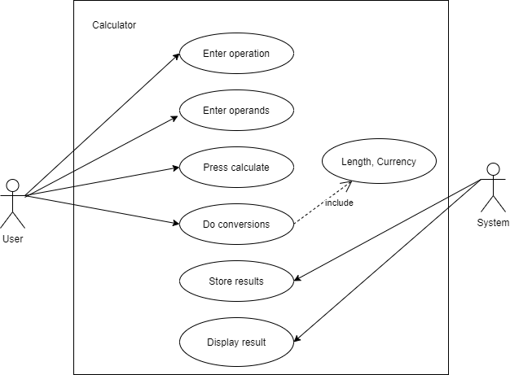

Fig.5 Use Case Diagram for calculator

## 3.2 Activity Diagram

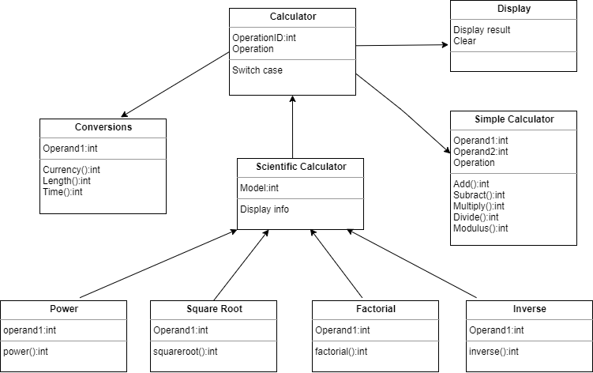

Fig.6 Activity Diagram for Calculator

# 4.Test Plan

|  |  |  |  |  |  |
| --- | --- | --- | --- | --- | --- |
| ID | Description | Pre-Condition | Expected input | Expected output | Actual output |
| T_01 | Work For function add | Operands must be integers | 7+26 | 33 | 33 |
| T_02 | Work For function add | Operands must be integers | 234578+345698 | 580276 | Error: Output value is in double |
| T_03 | Work for function multiply | Operands must be integers | 2*4 | 8 | 8 |
| T_04 | Work for function multiply | Operands must be integers | 2456*3456 | 8487936 | Error: Output value is in double |
| T_05 | Work for function divide | Operands must be integers | 7/0 | Divide by zero error | Divide by zero error |
| T_06 | Work for function square root | Operand must be integer | 25 | 5 | 5 |
| T_07 | Work for function square root | Operand must be integer | 8 | 2.82 | 2 since return value is in integer. |
| T_08 | Work for function  currency | Operand must be integer | 2 | 148 | 148 |
| T_09 | Work for function  currency | Operand must be integer | 2.5 | Error | Error: input should be integer |
| T_10 | Work for function  currency | Operand must be integer | 2,5 | Error | Error: only one operand is required |

# 5.Appendix

<https://github.com/Vinay2630/Calculator>

# 6.References

1. <https://beebom.com/best-calculator-apps-android/>

2. <https://github.com/stepin654321/MiniProject_Template/tree/master/.github/workflows>

3. <https://www.geeksforgeeks.org/>